Date: _____________

Today, your child, _______________________________, received a strike for improper use of his/her BYOD device. This is your child’s _______ strike on a three strike system.

Reason for strike: _____________________________________________________

Consequence:
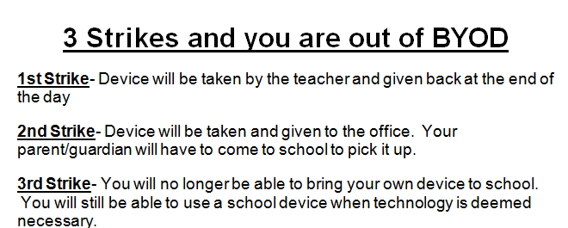

Please sign and return to your teacher by tomorrow.

Student Signature: ________________________________

Parent Signature: _________________________________

Teacher Signature: _________________________________

